Auction System User Manual

**Contents**

1. Account
   1. Register an Account ……………………………………………..2
   2. Login ……………………………………………………...……….3
   3. Logout …………………………………...……………...…………4
   4. Forgot Password …………………………………………………5
   5. Change Password ………………………………………………..6
   6. Account details …………………………………………………...7
   7. Change Personal Details ………………………………………..8
   8. Add payment Details …………………………………………….9
   9. Purchases List …………………………………………………..10
   10. Become a Seller ………………………………………………...11
2. Bidding
   1. List new Auction ………………………………………………...12
   2. Current User Auctions List ………………………………..…...13
   3. Activate an Auction for Bidding ………………………….…....14
   4. Lookup an Auction ...……………………...………..……….….15
   5. Make a Bid ……………………………………………………....16

Register an Account

1. To create an account, we locate the register button in the top right of the page and click on “Register”:



1. Next, a popup window will appear, please fill the details as indicated:

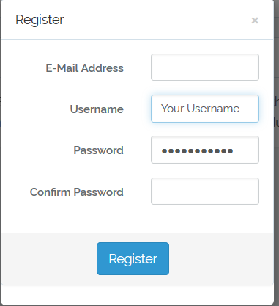

1. When finished, proceed by clicking on “Register” button. A popup window will indicate the success of the operation.



1. Finally, please proceed to step 1.2. to login to your account.

Login

1. Firstly, Locate the login button in the top right corner of the page and click on it:



1. A login popup window will appear asking for your details, please fill them as indicated and click “Login” (In case you forgot your password please go to step 1.4.):

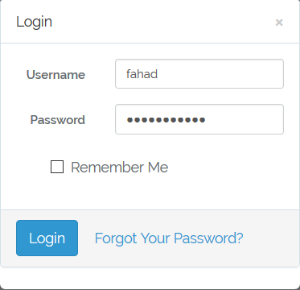

1. Upon successful login, a popup window will indicate a successful login operation:



Logout

1. Locate Your name in the right top corner of the page and click on it:



1. Upon clicking on the item a popup window will appear, click on “logout” button to logout from your account:

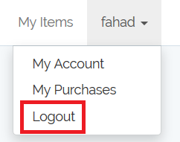

1. Upon successful logout, a popup window will indicate a successful logout operation:



Forgot Password

1. Firstly, Locate the login button in the top right corner of the page and click on it:



1. A login popup window will appear, Locate the “forgot your password” button and click on it:

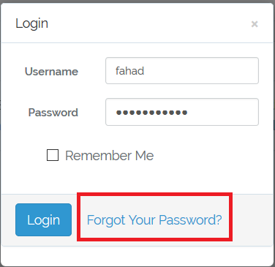

Change Password

1. Locate Your name in the right top corner of the page and click on it:



1. Locate and Click on “My Account” button:

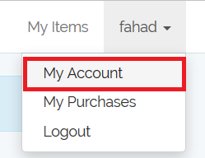

1. Next, the account page will appear. Locate “change” button next to the label “password” and click on it:

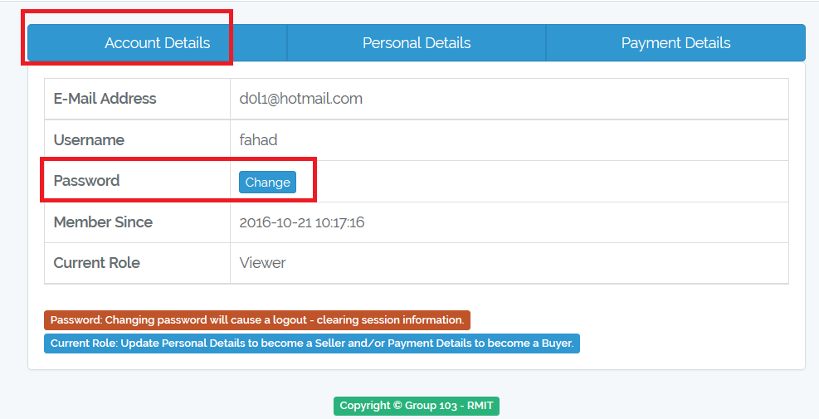

1. After that, a popup window will appear please fill as indicated and click “Submit” button:

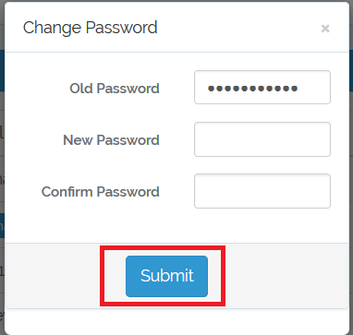

Account details

1. Locate Your name in the right top corner of the page and click on it:



1. Locate and Click on “My Account” button:



1. Next, the account page will appear:

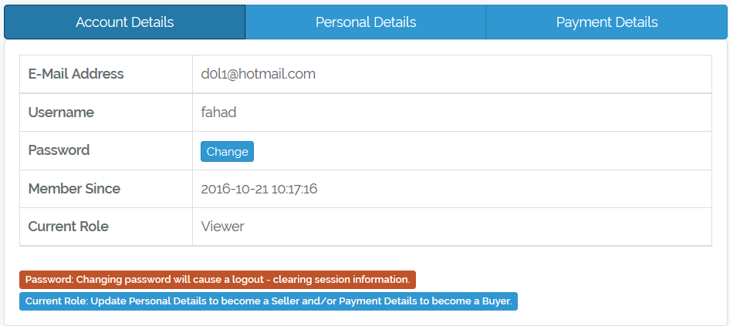

Change Personal Details

1. Locate Your name in the right top corner of the page and click on it:



1. Locate and Click on “My Account” button:



1. Next, the account page will appear:



1. Locate “Personal Details” button and click on it:

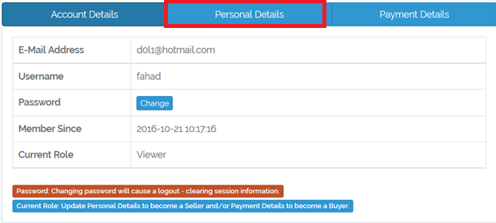

1. Personal details page will appear, please fill as indicated and click on “Update” button:

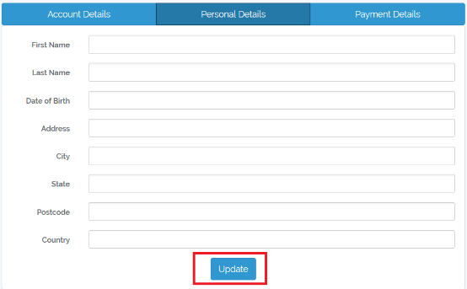

Add payment Details

1. Locate Your name in the right top corner of the page and click on it:



1. Locate and Click on “My Account” button:



1. Next, the account page will appear:

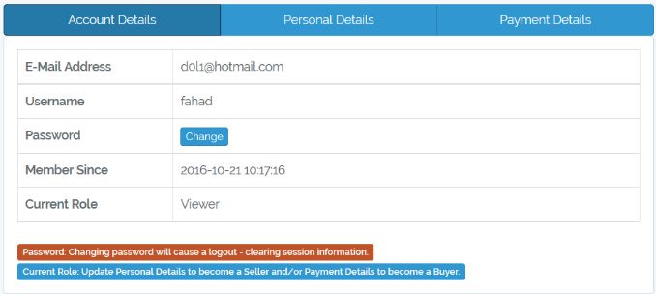

1. Locate and click on “Payment Details” button:

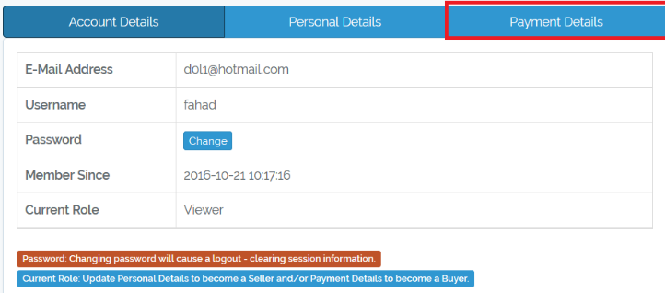

1. Payment Details page will appear, please fill as indicated and click on “Update” button:

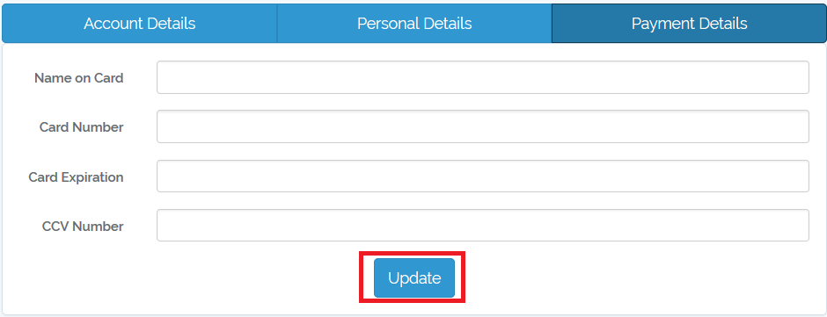

Purchases List